LESSON: Spins
OBJECTIVE:
To develop the students understanding of Spins
ELEMENTS:
Elements of spins
- Anxiety factors associated with spin instruction
- Aerodynamics of spins
- Airplanes approved for the spin maneuver based on airworthiness category and type certificate
- Relationship of various factors such as configuration, weight, center of gravity, and control coordination to spins
- Flight situations where unintentional spins may occur
- How to recognize and recover from imminent, unintentional spins
- Entry procedure and minimum entry altitude for intentional spins
- Control procedure to maintain a stabilized spin
- Orientation during a spin
- Recovery procedure and minimum recovery altitude for intentional spins
Common errors related to spins
- Failure to establish proper configuration prior to spin entry
- Failure to achieve and maintain a full stall during spin entry
- Failure to close throttle when a spin entry is achieved
- Failure to recognize the indications of an imminent, unintentional spin
- Improper use of flight controls during spin entry, rotation or recovery
- Disorientation during a spin
- Failure to distinguish between a high speed spiral and a spin
- Excessive speed or accelerated stall during recovery
- Failure to recover with minimum loss of altitude
- Hazards of attempting to spin an airplane not approved for spins
SCHEDULE:
- 20 Minutes Total
EQUIPMENT:
- Appropriate textbooks
- Chalkboard & chalk
- Model aircraft
- Appropriate slides/Visual Aids

INSTRUCTORS ACTIONS:
- Discuss lesson objective
- Introduce the concept of spins
- Discuss Elements of and common errors related to spins
- Ask pertinent questions to determine students understanding
- Assign appropriate study material
STUDENTS ACTIONS:
- Listen, take notes, ask questions
- Respond to instructors questions
- Leave with a framework understanding of the subject

COMPLETION STANDARDS:
The student should demonstrate adequate understanding of Spin entry and recovery.

Introduction
Attention/Motivation
To the misinformed pilot a spin and tight steep spiral can look quite similar. However, the recovery techniques are quite different and attempting to recover from a spin with a steep spiral technique will only make a bad situation worse. An understanding of spins and spin recovery is important because spins can develop suddenly and unintentionally if the pilot becomes distracted or uses poor stall recovery technique.
Overview
This lesson discusses elements of spins and spin recovery, and common errors related to Spins and Spin recovery
DEVELOPMENT
Elements of spins
Aerodynamics of spins AFH 4-13
- A spin is an aggravated stall that typically occurs from a full stall occurring with the airplane in a yawed state (uncoordinated flight) and results in the airplane following a downward corkscrew path.
- A spin is a condition where the airplane is autorotating around the vertical axis, with the outboard wing less stalled than the inboard wing, which creates a rolling, yawing, and pitching motion
- The rotation results from and unequal AOA on the airplane’s wings
- The less-stalled rising wing has a decreasing AOA, where the relative lift increased and the drag decreases. Meanwhile, the descending wing has an increasing AOA, which results in decreasing relative lift and increasing drag.

- A spin occurs when the airplane’s wings exceed their critical AOA (stall) with a sideslip or yaw acting on the airplane at or beyond the actual stall.
- An airplane will yaw not only because of incorrect rudder application but because of adverse yaw created by aileron deflection , engine/prop effects, wind shear, & wake turbulence.
- A stall that occurs while the airplane is in a slipping or skidding turn can result in a spin entry and rotation in the direction of rudder application, regardless of which wingtip is raised.
- Maintaining directional control and not allowing the nose to yaw before stall recovery is initiated is KEY to averting a spin.
- An airplane must be stalled and yawed in order to enter a spin.

Phases of a spin:
Entry Phase AFH 4-14
- The pilot provides the necessary elements for the spin, either unintentionally or intentionally
- Choose an area that has suitable emergency landing areas
- Choose an altitude (4,000’ AGL as per POH) that will allow recovery no lower than 1500 feet AGL
- Begin with a stall in the specified configuration
- As the airplane approaches a full stall smoothly apply full rudder in the direction of the desired spin
- Use neutral ailerons and full aft elevator
Incipient Phase AFH 4-14
- From the time the airplane stalls and rotation starts until the spin has fully developed
- This may take up to two to four full rotations
- Aerodynamic forces and inertial forces have not yet achieved a balance
- As the incipient spin is developing the airspeed indicator should be near or below the stall speed
- The turn coordinator will indicate the direction of the spin
- The slip/skid indicator ball is unreliable when spinning.
Developed Phase AFH 4-15
- The airplane’s angular rotation rate, airspeed, and vertical speed are stabilized
- The airplane’s flight path is vertical or near vertical
- Aerodynamic forces and inertial forces are in balance
- The airplane’s attitude, angles, and self-sustaining motions about the vertical axis are constant or repetitive, or nearly so.
- The spin is in equilibrium
Recovery Phase AFH 4-15
- Occurs when the angle of attack of the wings decrease below the critical angle of attack, and autorotation ceases
- To recover, the pilot applies control inputs to disrupt the spin equilibrium by stopping the rotation and unstalling the wing.

Recovery Steps ( P.A.R.E. ) AFH 4-15
- Reduce Power ( P )
- Power makes the spin worse
- Results in a flatter spin with a faster rotation rate
- Position the Ailerons to Neutral ( A )
- Aileron input in the direction of the spin could make the spin faster
- Aileron input in the direction opposite the spin can cause the wing with the down aileron to become even more stalled making recovery more difficult
- Apply Full Opposite Rudder ( R )
- Rudder pedal should be at the stop

- If unsure which direction to apply rudder due to disorientation, use the turn coordinator to determine spin direction
- Apply a Positive and Brisk, Forward Elevator Control Pressure ( E )
- This will lower the angle of attack and break the stall
- After the Spin Rotation Stops, Neutralize Rudder
- If rudder input is left in, a spin in the opposite direction could occur
- Apply Smooth Elevator Back Pressure to Raise the Nose to Level Flight
- Abrupt control movements could cause a secondary or accelerated stall

Spin Factors AFH 4-14 / 4-16
- Before attempting to perform intentional spins perform a thorough preflight to include:
  - Ensuring the airplane does not have any spin limitations and/or complying with any spin limitations (Weights, CG ranges, flap settings, etc.) to ensure the airplane remains in the utility category
    - With an aft CG the elevator has less effective arm, and recovery could be more difficult
2. Securing loose items in the cabin

Common errors related to spins AFH 4-17
- Failure to establish specified configuration prior to spin entry
- Failure to achieve and maintain a full stall during spin entry
- Failure to close throttle when a spin entry is achieved
- Failure to recognize the indications of an imminent, unintentional spin
- Improper use of flight controls during spin entry, rotation or recovery
- Disorientation during a spin
- Failure to distinguish between a high speed spiral and a spin
- Excessive speed or accelerated stall during recovery
- Failure to recover with minimum loss of altitude
- Hazards of attempting to spin an airplane not approved for spins

CONCLUSION
- A spin occurs when the airplane’s wings exceed their critical AOA (stall) with a sideslip or yaw acting on the airplane
- Occur as a result of improper rudder use during the entry and/or recovery from the initial stall
- To perform use the published spin entry procedures
- Recovery is performed by using the P.A.R.E. procedure
- Proper explanation and effective demonstration is essential for student understanding
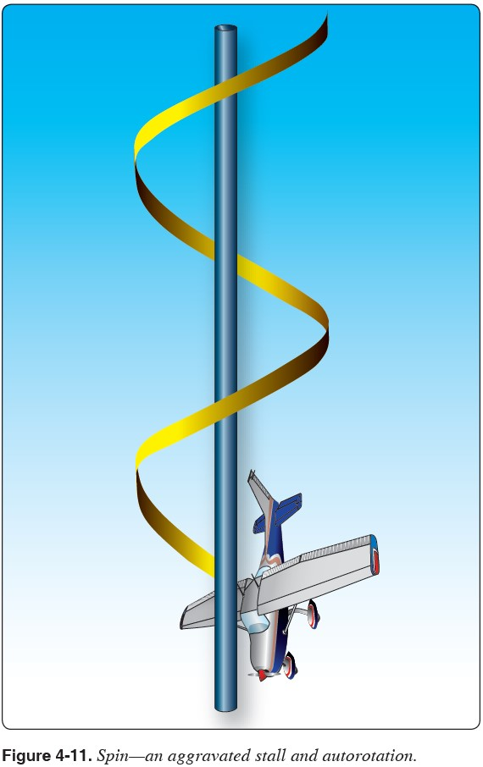

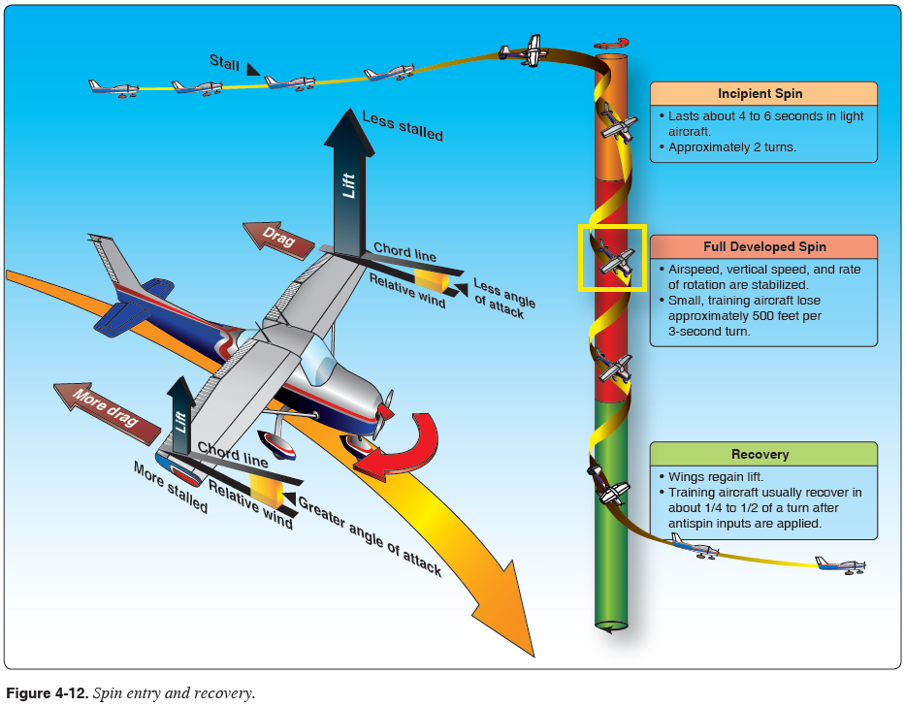

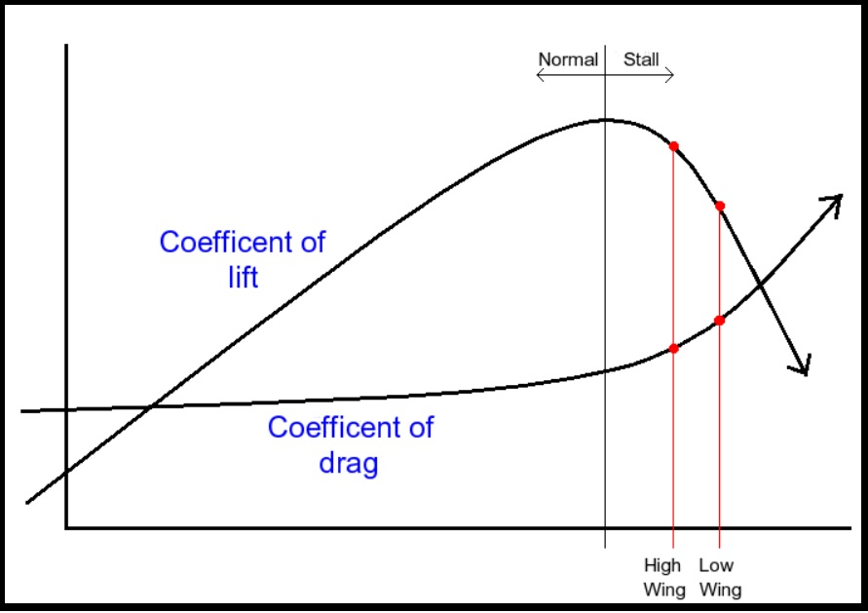
Aerodynamic spin diagram: Lift and Drag Coefficients vs. Angel of Attack
